

Daffodil International University

Department of Software Engineering Faculty of Science & Information Technology

**Mid-Term Overlap Exam, Fall 2021**

**Course Code: SE 544 (CC)**

**Course Title: Introduction to Machine Learning**

**Level: 4 Term: 1 Section: A**

**Teacher Initial: MSA Total Marks: 25**

Texts in square brackets indicate Course Learning Outcomes and Bloom's Taxonomy Levels

1. Describe Machine Learning and its use with example. [CLO1 , Level 01] **03 Marks**

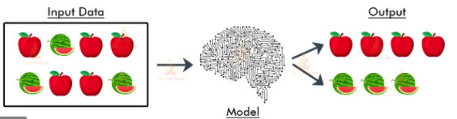

2. Analyze the above Picture carefully and explain which learning it was, how you can get the desire answer using which type of algorithms. [CLO2, Level 4] **07 Marks**

3.

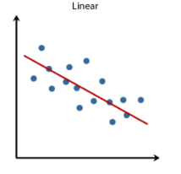

Decide what type of Regression it is. Explain How the Hypothesis equation works with Demonstration.

[CL0 2, Level 6] **4Marks**

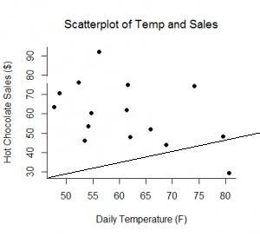

4.

Calculate the Cost Function or error for temperature 55 and 60 for actual and predicting value.

[CL02, Level 03] **06** **Marks**

5. Calculate the Matrix and Vector Multiplication. Also explain About Transpose Metrix with example.

[CL02, Level 03] **05 Marks**

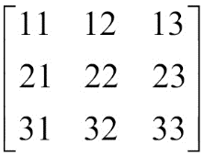

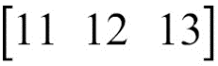Y = and A =